Dear Parents and Students,

Choir rocks! Greetings and welcome to what will be an exciting year of Women’s Chorus at St. Johns High School. I am Mrs. Eller and I look forward to getting to know each student as an individual and helping them to grow and appreciate the art of vocal music.
I am so glad you have chosen to take this class and to be a part of a wonderful ensemble. We will be focusing a lot on challenging ourselves, as singers, beyond the basics and fundamentals of singing such as breathing properly, posture and proper vowels. This class offers an amazing opportunity for each student to grow musically, vocally and personally to the fullest potential. I encourage all students to dare to push their limits and truly have a great experience in vocal music at St. Johns.
This handbook has been designed to give parents and students an overview of the director’s expectations, guidelines, rules, grading procedures, and tips on becoming the BEST musician possible. Please read it through carefully. If you have a question/concern at any time during the year, consult the handbook first. If you cannot find your answer, then please don’t hesitate to contact us. Communication with students and parents is very important to me and to the success of our vocal music program.
The choir room is a safe place for students and any negative behavior will not be accepted. If you follow the rules in this handbook, we can have a very successful year together and gain experiences you may not find anywhere else. My goal is for you to leave this class with a sense of pride, self-confidence, self-satisfaction and a thirst for more!
I am so excited to kick-off this year and begin making music.
Singcerely,
Mrs. Nichole Eller
Vocal Music Director
St. Johns High School and Middle School
(989) 227-4274
Ellern@sjredwings.org

Check out the new Choir Website! sjpschoir.weebly.com

Please read the handbook and turn in the last page to Mrs. Eller by Monday, September 14th.

Why Music?

Music is a Science.
It is exact, specific, and it demands exact acoustics. A conductor’s full score
is a chart, a graph that indicates frequencies, intensities, volume changes,
melody, and harmony all at once and with the most exact control of time.

Music is Mathematical.
It is rhythmically based on subdivisions of time into fractions, which must be
done instantaneously, not worked out on paper.

Music is a Foreign Language.
Most of the terms are in Latin, Italian, German, or French, and the notation is
certainly not English – but a highly developed kind of shorthand that uses
symbols to represent ideas. The semantics of music is the most complete
and universal language.

Music is History.
Music usually reflects the environment and time of its creation, and often
times the country of origin.

Music is Physical Education.
It requires fantastic coordination of fingers, hands, arms, lip, cheek, and
facial muscles in addition to extraordinary control of the diaphragmatic, back,
abdominal, and chest muscles, which respond instantly to the sound the ear
hears and the mind interprets.

Music develops Insight and Demands Research.
Music is all these things, but most of all: music is ART! It allows a human being to take all the difficult techniques and use them to create emotion.

Music promotes:
Problem Solving Skills
Teamwork
Goal Setting
Self-expression
Coordination
Memory Skills
Self-confidence and self-esteem
Concentration
Poise and confidence
Higher SAT and ACT scores
Stronger higher-order thinking skills such a spatial reasoning

Classroom Expectations
- BE ON TIME – You are expected to be quickly making your way to your seat when the bell rings. This means that you also have your pencil, binder and music. (Pencils ONLY)
- BE PREPARED
- BE RESPECTFUL – This applies to your peers, your teacher, any classroom guests and the instruments that are in the room.
- BE CREATIVE – Music is art, creativity is welcomed

Every child is unique and consequences will vary on each individual situation. If a student fails to adhere to classroom expectations, the teacher and student will come to an agreement on the appropriate action. Some examples may include: detention, note/call home, office referral, etc.

I appreciate your support at home and your willingness to encourage your student to be consistently successful in music.

Grading Policy
Students are graded at the end of each academic trimester with a progress report halfway through.

Rehearsal/Participation Expectations (5 pts/day = 25 points/week) (20%)
Each student is expected to come to class prepared.
- Each student can earn up to 5 participation points each class. Throughout weekly classes, students will be evaluated on their level of participation and effort towards following classroom expectations.
- The penalty for chewing gum will increase the more a student is caught chewing gum. For example, 1 point for the first time caught, 2 for the second time and so on.
I care about YOU and don’t want you choking while taking a good ole healthy singer’s breath
- Students will also lose 2 points for being tardy. We work as a team and need you here on time!

Performance Expectations (40%)
Performances are why we put all the hard work in during rehearsal. It’s your chance to showcase all that you learned and to finally get the experience in performing. With that said, performances are MANDATORY. Please make sure to mark the performance dates in your calendar to avoid any scheduling conflicts. Always keep the performances in mind while scheduling anything.
If there is a school-related conflict, the student is expected to notify the coach/teacher in a timely fashion. The teacher, coach and principal will then decide how best to resolve the conflict. 95% of the time things can be worked out so that the student can participate in both events. If participation in both events is NOT a possibility, the decision about which event the student will participate in becomes the responsibility of the St. Johns staff.
(Continued on next page…)
There are two types of absences from choral performances: excused and unexcused.
- Excused Absence – An absence is excused if, and only if:
- You are ill and are out of school the FOLLOWING day (a note is required)
- There is a family emergency (a note is required)
Excused Absence performance points CAN be made up. You must attend an approved concert and write a descriptive paper about your experience, or work on another approved music-related project. It is the student’s responsibility to initiate the make-up procedures; failure to do so will result in a complete loss of points for the concert.
- Unexcused Absence – An unexcused absence occurs when you miss a concert and are NOT ill and out of school the following day or there is NO family emergency. The points lost due to an unexcused absence cannot be made up.
Students will also lose points for the following:
- Tardiness
- Not dressed in the appropriate performance attire
- Not following directions during the pre-concert warm-ups and procedures
The rules have been put in place to stress the importance of performances. Remember: Choir works as a team and we need every player to do our best!

Quizzes (10%)
Students will take quizzes based on concepts covered in class. Quizzes are normally announced, but the director holds the right to give pop (unannounced) quizzes if necessary.

Tests (20%)
Students will have a few tests per marking period. The tests will be both written and performance based. They will cover concepts covered in class and an accumulation of quizzes. Some singing tests will be done in class in groups. Your behavior while others are testing WILL result in your final test grade.

Portfolios and Theory (10%)
All students are required to keep and maintain a portfolio. Students will keep theory assignments, evaluations, feedback sheets, handouts, etc… in these portfolios. Students are encouraged to use a one-inch three-ringed binder that has a plastic insert cover on the front for this portfolio along with THREE dividers. It WILL be graded on neatness, organization and content. Theory will be graded on a point system but still be part of the 10% of your final grade.

Tardy Policy
It is the expectation that all students be in their seats, ready to sing at the time the bell rings. Class begins with vocal and physical warm-ups designed to encourage healthy and successful singing. It is imperative that all students are ready to participate in the beginning rehearsal procedures. 1st tardy will result in a warning. After that, students will lose 2 points every time they are tardy and normal school procedures will apply.
Music
Each student in the choir will receive music. The music is to stay in the choir room. If music is lost, damaged, or misplaced, the student will be responsible for its replacement costs. (Usually $2). Students may sign out their folders to take home and practice.

Seating Charts
Seating charts are altered occasionally during the year. If your students is uncomfortable with where they have been placed, please contact me. Your opinion is welcome.

Leadership Opportunities
Leadership roles will be appointed in the classroom to make rehearsals run smoothly and will be decided within the first two weeks of class.

Remember: This is YOUR choir and we need students to step up and get excited! I know I am!!
If you would like to be considered for a leadership role please check the class leadership box on the last page!

Fundraising
Throughout the year there will be various vocal music fundraisers. We use this money to support trips, and purchase things that are essential to our program! Mrs. Eller needs everyone’s help and commitment to make fundraisers as successful as possible. The more each student can participate in fundraisers, the more I can do for you and offer you!

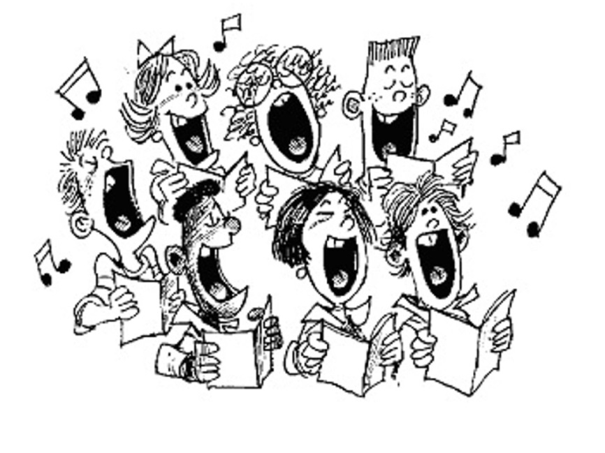

Students should have a binder and 3 dividers by Monday, September 14th. One participation point will be lost for every day a student does not have it.
Important/Mandatory Concert Dates
Please arrange rides accordingly so that students make their call time.
Early is on time. On time is late.

2015
Thursday October 29th – Fall Choir Concert @ 7:00pm (at the HS)
- Doors open @ 6:30pm
- Call time for MS students is 5:15pm in the HS Choir Room
Tuesday December 15th – Winter Concert Dress Rehearsal @ 6:00pm
- At the HS
Wednesday December 16th – Winter Choir Concert @ 7:00pm (at the HS)
- Doors open @ 6:30pm
- Call time for MS students is 5:15pm in the HS Choir Room

2016
Wednesday March 2nd – MSVMA Pre-Festival Concert @ 7:00pm (at the HS)
- Doors open @ 6:30pm
- Call time for MSS students is 5:30pm on the stage
Tuesday or Wednesday March 8-9 – MSVMA Choir Festival @ CMU
- Official dates and times will be released in February
Tuesday June 7th – Spring Choir Concert @ 7:00pm in the MS Auditeria
- Doors open @ 6:30pm
- Call time for MS students is 5:30pm

Please take the time to check the dates with your calendar, write them down, and report any issues to me immediately. This page would look GREAT on your fridge

Uniforms
Students are required to wear all black for our performances. The choir will vote on an accent color and will be allowed to spice up their outfit with a touch of color!
ALL BLACK MEANS:
- Black DRESS shoes (close-toed and close-heeled) – Not black tennis shoes, not black flip-flops – black DRESS shoes. Ladies: No higher than 2” heels
- Black socks – Do not show up with white socks and all black dress attire. You might look a little silly.
- Black Slacks/Dress Pants – no skirts, shorts, jeans or spandex.
- Black Dress Shirt – The shirt may be short or long-sleeved for the female singers. Male singers will have to wear a tie, so a black button-up shirt will be your best option. Tie should be the color of the chosen accent color.
Please return this page to Mrs. Eller by Monday, September 14th and show that you have your binder with dividers!

Student Name _______________________________________________________________________________
Grade___________

_____ Interested in a leadership role

Parent/Guardian Names__________________________________________________________________

By signing this form, you and your student acknowledge that you have read the vocal music handbook and agree to the policies stated.

Parent/Guardian Signature_______________________________________________________________

Student Signature__________________________________________________________________________

Choir Rocks!

